Periodic Table Review 2016 KEY
- Label the blank periodic table with the appropriate terms.
- Metalloids along stairs except Al B. Element that has the highest electronegativity flourine
- Alkali metals first group D. Lanthanide series first row on f block
- Element with the greatest atomic radius Francium F. Noble gases last group
- Halogens Group 17 H. Alkaline Earth metals second group
- Transition metals d and f block J. s, p, d and f blocks look in notes

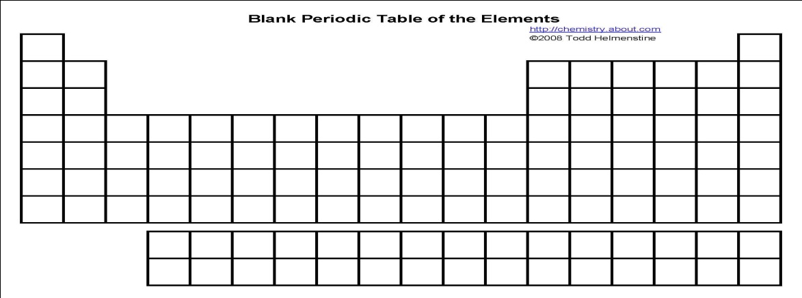

- What trend is depicted in the picture below? Explain why this trend exists. Radius – atoms increase in size as go down the group because are adding electrons on different energy levels. Atoms get smaller as go across the period as electrons are being added on the SAME energy level and the positive nucleus is attracting them – pulling them in closer.

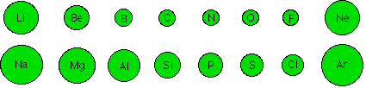

- Explain the significance of the stair step line located near the right hand side of the periodic table. It separates the metals from the nonmetals.
- List the metalloids. Which element seems like it should be a metalloid but is really a metal? B, Si, Ge, As, Sb, Te, Po, At
Aluminum is not a metalloid – it is a metal

- What are some characteristics of metalloids? Share some characteristics of metals and some of nonmetals (ie, may conduct electricity better than nonmetals but not as well as metals)
- Which element has the greatest atomic radius:
  - Mg or Cl
  - Sr or Ba
- Which element has the lowest electronegativity:
  - C or F
  - Be or Ba
- Explain why argon comes before potassium on the modern day periodic table. How would the placement have been different if we used Mendeleev’s version of the periodic table? The table is arranged by increasing atomic number and it used to be arranged by atomic mass (Ar has a lower atomic number than K)
- Why do elements in the same group have similar properties?
They have the same number of valence electrons

- Use the periodic table to write the names of the third alkali metal, the first transition metal, and the last noble gas.
K, Sc, Rn

- An element has an atomic number of 80. How many protons and electrons are in the atom?
80 protons, 80 electrons
- What is the usual charge on any ion located in group 7A? 1-
- How many electrons does Ca²⁺ contain? 18
- What is an ion called that has gained electrons? _anions___ One that has lost electrons? _cations_____
- How many valence electrons do most atoms want? __8_______ Why? To have a full outer energy level like noble gases
Matching: Match all correct choices with the correct person. Choices can be used more than once! Some answers will require more than one answer to be correct.

a. organized periodic table by atomic number
b. first person to organize the elements into groups
c. left spaces for elements that had not been discovered yet
d. arranged the elements into triads (groups of three)

16. Dobereiner ___d_______
17. Moseley ___a_______
18. Mendeleev ___c______
19. Lavosier __b________

- Identify three characteristics of metals. 1.lustrous 2. ductile 3. malleable 4. Good conductor
- Identify three characteristics of nonmetals. 1. dull 2. brittle 3. Poor conductor
- Identify the element located in group 6A and period 4. Se
- Identify the element with more protons than aluminum, but less protons than chlorine, and has 5 valence electrons. P
- How many valence electrons do the following elements have:
  - Mg 2 b. F 7 c. Na 1 d. N 5 e. S 6 f. Kr 8
- Which group has the ending configuration of s¹? __IA___________ Of p⁴? ___VIA_________
- The most nonreactive atoms are the _____Noble Gases__________.

- Draw an electromagnetic spectrum and label the following: see diagram in notes
  - Microwaves e. Ultraviolet light
  - Visible light (include the different colors) f. Infared light
  - Gamma rays g. X-rays
  - Radio waves
- Which one has the greatest frequency? Gamma
- Which one has the longest wavelength? Radio
- Which one has the lowest energy? Radio
- Does red or violet light have the greatest frequency? Violet
- Explain why electrons move up energy levels when they gain energy. They absorb energy and move up levels – they release energy as they return to their ground state – this energy is released as light waves in various colors.

